CPU Design
Version 0.1
David Lowther

Revision History
11 Jun 2026 | First Draft
12 Jun 2026 | Added new section (deleted 20 Jun)
18 Jun 2026 | Defined ALU_MODE in 3.8 Table 2  Redefined flags in 3.9 and added new sub sections 3.9.*
19 Jun 2026 | Added note about ALU_MODE time when this value is correct in 3.8
20 Jun 2026 | Edit Figure 1 to remove “GP Regs & SP Reg” block.  Added new section 2.1.1 to explain rules for reading from the data bus  Including IS may read from the data bus (for e.g. CPY Ra,Rb which are now in RAM)  Added new section in Overview of the Data Bus to explain rules for writing to the data bus  Added new section 2.2 to explain that GP regs (including SP) will be in RAM.  Removed what was section 3.7 “REG CTRL BUS”  Removed what was section 4 “16 Bit Register Component” and all of sub sections 4.*
21 Jun 2026 | Added new section 2.2.1 SP Behaviour
24 Jun 2026 | Added RAM address bus (only affects ALU and RAM blocks):  - Figure 1 updated  - 3.6 Removed text about RAM address latch  - 3.7 New section defining RAM ADDR Bus
29 Jun 2026 | Added timing diagram for data bus transfers Figure 2 in 2.1  Added text below Figure 2 to explain how transfers work  Changed 2.1.1 to define how to use a level enabled latch as well as the (already defined) method for using an edge triggered latch
30 Jun 2026 | Remove READ and WRITE
2 Jul 2026 | Add RESET to 3.4 PC CTRL bus and 3.1 Common bus signals
4 Jul 2026 | Changes to match ref 2 signals changing from active low to active high

Contents
1 Introduction 1
2 Overview 1
2.1 Overview of the Data Bus 2
2.1.1 Reading from the Data Bus 3
2.1.2 Writing to the Data Bus 3
2.2 Overview of GP and SP registers 4
2.2.1 SP Behaviour 4
3 Other Busses 4
3.1 Common bus signals 4
3.2 ADDRESS bus 4
3.3 OP CODE bus 5
3.4 PC CTRL bus 5
3.5 IO CTRL bus 6
3.6 RAM CTRL bus 6
3.7 RAM ADDR Bus 6
3.8 ALU CTRL bus 7
3.9 FLAGS bus 8
3.9.1 Flags whose rules are fixed regardless of the ALU_MODE 8
3.9.2 Flags whose rules depend on the ALU_MODE 8
4 References 10

Figures
Figure 1: Top Level Block Diagram 1
Figure 2: Data Bus Transfer Timing Diagram 2

Introduction
The purpose of this document is to define how the blocks within the CPU will communicate with each other via the Data Bus and how the Instruction Sequencer (IS) can control that communication for each opcode.

Overview
Figure 1 shows an overview of the control signals and the data bus.
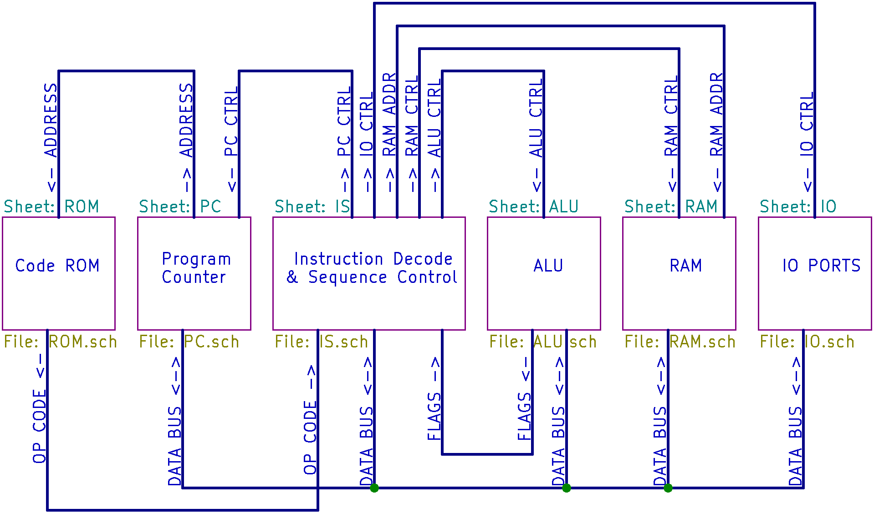
Figure 1: Top Level Block Diagram
Table 1: Key to Figure 1
Symbol | Meaning
The blue lines are busses. Each bus contains one or more wires.
The data bus and op code bus contain 16 wires
 | These symbols indicate that the signal on the bus flows only in one direction, as shown by the arrow.  The signals on these busses are always being driven by the output device, unlike the data bus these outputs will never be tri-state high impedance.
 | This symbol, only used for the data bus, indicates that the signal on the bus can flow in either direction.

Overview of the Data Bus
This is the most important bus shown in Figure 1. It is this bus that provides the path to transfer 16 bit values from one block to another.
The timing diagram for data bus transfers is shown in Figure 2.
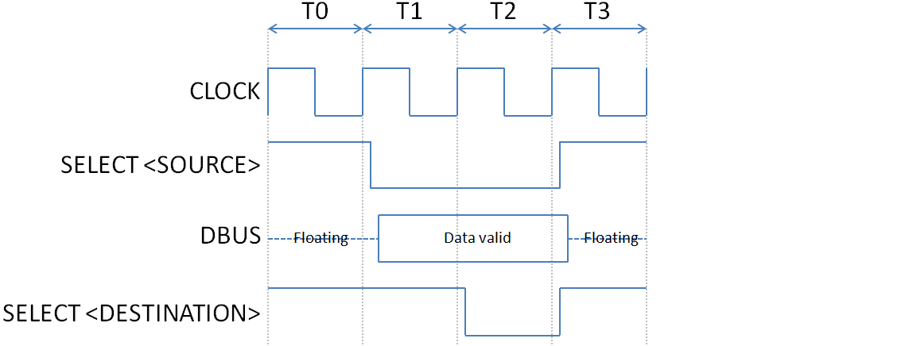
Figure 2: Data Bus Transfer Timing Diagram
In the following text: “signals” are all the named signals in Figure 2 excluding CLOCK.
The signals shown in Figure 2 are all set to the required state a short time after the rising edge of CLOCK. “Rising edge” means when CLOCK changes from high to low.
T0 is the initial state.
- All SELECTs are all high. The data bus is floating.
T1 is the start of the data bus transfer
- SELECT <SOURCE> goes low a short time after the rising edge of T1 CLOCK.
- DBUS becomes valid a short time after SELECT <SOURCE> goes low.
T2 is the end of the data bus transfer
- DBUS is valid at the start of T2
- SELECT <DESTINATION> goes low a short time after the rising edge of T2 CLOCK.
- The selected destination should read the value from DBUS on the falling edge of SELECT <DESTINATION>
T3 returns to the initial state
- All SELECTs go high a short time after the rising edge of T3 CLOCK
- The data bus returns to floating a short time after SELECT <SOURCE> goes high.
The short times referred to in the above text are due to propagation delays. All chips take a finite time to change their outputs after a change on their inputs. These times are small and are usually << 1µs per chip.

Reading from the Data Bus
All blocks that are capable of reading from the data bus will have an input to select which device in the block should read from the data bus.
Select signals names are the form “SELECT_<name>_DEST<optional qualifier>”.
- For example, the ALU has two devices that can read from the data bus, Input Latch A, and Input Latch B.
- The select signals for those two devices are named: SELECT_ALU_DESTA and SELECT_ALU_DESTB.
The IS controls what is reading from the data bus. The IS may read from the data bus. The relevant SELECT signals are internal to the IS block. Hence they are not shown in Figure 1.
Reading from the data bus is controlled by the relevant SELECT_x_DESTx signal.
The rules for reading are:
- If SELECT_x_DESTx is HIGH, then the device controlled by this signal ignores the data bus value
- Reading using an edge triggered latch
  - Read on falling edge of SELECT_x_DESTx
- Reading using a latch with a read enable signal that depends on a level, not on an edge
  - Read when (!SELECT_x_DESTx AND CLOCK) is low

Writing to the Data Bus
All blocks that are capable of writing to the data bus will have an input to select which device in the block should write to the data bus.
Select signals names are the form “SELECT_<name>_SRC<optional qualifier>”.
- For example, the ALU has one device that can write to the data bus, the ALU result.
- The select signal for that device is named: SELECT_ALUO_SRC.
The IS controls what is writing to the data bus. The IS may write to the data bus. The relevant SELECT signals are internal to the IS block. Hence they are not shown in Figure 1.
Writing to the data bus is controlled by the relevant SELECT_x_SRCx signal.
The rules for writing are:
- If SELECT_x_SRCx is HIGH, then the device outputs are tri-state.
- If SELECT_x_SRCx is LOW, then the device should write to the data bus.

Overview of GP and SP registers
There will be 16 registers numbered R0 to R15. R15 will be the SP. All these registers will be 16 bit.
These registers will be implemented in the first 16 words of the 16 bit RAM. R0 at address 0 and R15 at address 15 (decimal)

SP Behaviour
The SP behaviour is:
- Before assembly code uses the stack it must initialise the SP to the start of an area of RAM that the coder has decided to use for the stack.
- SP always contains the address of the next free stack location.
- PUSH Ra: Writes the value of Ra to the RAM address specified by SP, then increments SP.
- POP Ra: Decrements SP then loads Ra with the value from the RAM address specified by SP.
- CALL Ra: Sets PC to the address following the CALL instruction then pushes PC.
- RET: Pops PC off the stack.

Other Busses
This section contains a sub-section for each of the busses, other than the data bus, shown on Figure 1, namely (from left to right on Figure 1 except the 1st one in the list):
- 3.1: Common bus signals (not shown explicitly on Figure 1, see 3.1 for details)
- 3.2: ADDRESS
- 3.3: OP CODE
- 3.4: PC CTRL
- 3.5: IO CTRL
- 3.6: RAM CTRL
- 3.8: ALU CTRL
- 3.9: FLAGS

Common bus signals
This isn’t shown as a separate bus on Figure 1. However, there will be some signals that are common to one or more of the other busses listed above, namely:
- CLOCK
- RESET
  - Starts low at power up, then changes to high after some time T on the rising edge of a CLOCK. T must be at least 2 clock periods. It may be much longer than that.

ADDRESS bus
This is simply the 16 bit output of the PC register. It’s always enabled and there are no other control signals associated with it.

OP CODE bus
This is simply the 16 bit output of the ROM. It’s always enabled and there are no other control signals associated with it.

PC CTRL bus
The Program Counter (PC) is basically a 16 bit register which can be read from the data bus, and written to the data bus, just like a GP register.
The PC has an additional feature which is it can be directly incremented (without using the data bus) by an “increment” signal.
Most instructions require the PC to be incremented in order to read the next instruction, or the 2nd word of the current instruction. This increment happens so often that it would be very inefficient (waste time) to increment it using the ALU, as that would require many more steps.
The PC also needs to be able to be output its value on the data bus (e.g. so that a call instruction can push it onto the stack) or read its new value from the data bus (e.g. for jump and return instructions).
The signals on this bus are:
- CLOCK (common defined in 3.1)
- RESET (common defined in 3.1)
  - Resets the PC to 0x0000.
- SELECT_PC_DEST:
  - Selects the PC to be the destination for something else writing to the data bus.
  - See 2.1.1 for details of how to read from the data bus.
- SELECT_PC_SRC:
  - Selects the PC to be the source that is going to write to the data bus.
  - See 2.1.2 for details of how to write to the data bus
- INC_PC:
  - Increments the PC by 1

IO CTRL bus
The relevant instructions are
- IN Ra,Rb : Ra = port number to read. Rb is set to value read from that port
- OUT Ra,Rb: Ra = port number to write. Rb is the value to write to that port
The signals on this bus are:
- CLOCK (common defined in 3.1)
- SELECT_PNL_DEST
  - Selects the Port Number Latch to be the destination for something else writing to the data bus.
  - See 2.1.1 for details of how to read from the data bus.
- SELECT_PVL_DEST
  - Selects the Port Value Latch, for the port whose number is contained in the Port Number Latch, to be the destination for something else writing to the data bus.
  - See 2.1.1 for details of how to read from the data bus.
- SELECT_PNV_SRC
  - Selects the Port Value Latch, for the port whose number is contained in the Port Number Latch, to be the source that is going to write to the data bus.
  - See 2.1.2 for details of how to write to the data bus

RAM CTRL bus
To read from, or write to RAM, the RAM address must first be put on the RAM ADDR bus (see 3.7).
The signals on this bus are:
- CLOCK (common defined in 3.1)
- SELECT_RAM_DEST
  - Selects the RAM to be the destination for something else writing to the data bus.
  - See 2.1.1 for details of how to read from the data bus.
- SELECT_RAM_SRC
  - Selects the RAM to be the source that is going to write to the data bus.
  - See 2.1.2 for details of how to write to the data bus

RAM ADDR Bus
This will contain up to 16 bits (for a 64K x 16 bit RAM). If the size is < 64K less bits will be required on the address bus. <tbd Earth to decide RAM size, but this isn’t urgent or blocking any work ATM>
The IS will write the correct value to this bus before doing any data transfers to / from RAM.

ALU CTRL bus
The signals on this bus are:
- CLOCK (common defined in 3.1)
- ALU_MODE
  - Defines what operation the ALU is going to perform.
  - This is a 3 bit value as shown in Table 2 :
Table 2: ALU_MODE bits and their meaning
Bit 2 | Bit 1 | Bit 0 | Mode | Result
0 | 0 | 0 | AND | Input A AND Input B
0 | 0 | 1 | OR | Input A OR Input B
0 | 1 | 0 | NOT | NOT Input A
0 | 1 | 1 | ADD | Input A + Input B
1 | 0 | 0 | SUB | Input A – Input B
1 | 0 | 1 | XOR | Input A XOR Input B
1 | 1 | 0 | Spare | Undefined
1 | 1 | 1 | Spare | Undefined
  - NB: The only operation, using both Input A and Input B, that depends on the order of input A and input B is SUB because A-B != B-A.
  - This 3 bit value will be correct before any data is sent to the ALU input latches and will continue to be correct until after the ALU result has been read.
- SELECT_ALU_DESTA
  - Selects ALU input latch A to be the destination for something else writing to the data bus.
  - See 2.1.1 for details of how to read from the data bus.
- SELECT_ALU_DESTB
  - Selects ALU input latch B to be the destination for something else writing to the data bus.
  - See 2.1.1 for details of how to read from the data bus.
- SELECT_ALUO_SRC
  - Selects the ALU output be the source that is going to write to the data bus.
  - Also causes the ALU to store the flags in the flags latch.
  - See 2.1.2 for details of how to write to the data bus

FLAGS bus
This is the output from the ALU flags latch. It’s always enabled for output. These signals are used by the Instruction Sequencer to decide whether conditional jumps should be followed or skipped.
The signals on this bus, which consists of 5 bits, one bit per flag, are:
- FLAG_S
- FLAG_V
- FLAG_N
- FLAG_Z
- FLAG_C
These flags, and the rules for how they should be set, are based on the AVR flags defined in ref 1.
The rules about setting the flags fall into two sets:
- Flags whose rules are fixed regardless of the ALU_MODE
- Flags whose rules depend on the ALU_MODE

Flags whose rules are fixed regardless of the ALU_MODE
The rules for these flags don’t depend on ALU_MODE:
- FLAG_S = FLAG_N XOR FLAG_V
- FLAG_N = ALU result bit 15
- FLAG_Z = 1 if the ALU result is 0x0000, else FLAG_Z = 0

Flags whose rules depend on the ALU_MODE
The rules for these flags do depend on ALU_MODE:
- FLAG_V
- FLAG_C
Table 3 shows the rules for these two flags.
Table 3: Rules for FLAG_V and FLAG_C
MODE | FLAG_V | FLAG_C
AND | Set to 0 | Not changed
OR | Set to 0 | Not changed
NOT | Set to 0 | Set to 1
ADD | See 3.9.2.1 | See 3.9.2.2
SUB | See 3.9.2.3 | See 3.9.2.4
XOR | Set to 0 | Not changed

The next 4 sections use the following nomenclature:
- A15 = ALU input A bit 15
- B15 = ALU input B bit 15
- R15 = ALU result bit 15
- ! = NOT

FLAG_V Rules for ALU_MODE = ADD
FLAG_V = (A15 AND B15 AND !R15) OR (!A15 AND !B15 AND R15)

FLAG_C Rules for ALU_MODE = ADD
FLAG_C = (A15 AND B15) OR (B15 AND !R15) OR (!R15 AND A15)

FLAG_V Rules for ALU_MODE = SUB
FLAG_V = (A15 AND !B15 AND !R15) OR (!A15 AND B15 AND R15)

FLAG_C Rules for ALU_MODE = SUB
FLAG_C = (!A15 AND B15) OR (B15 AND R15) OR (R15 AND !A15)

References
- AVR Instruction Set Manual
- L1IsSequences.xlsx

